**Leonardo Reis de Brito**

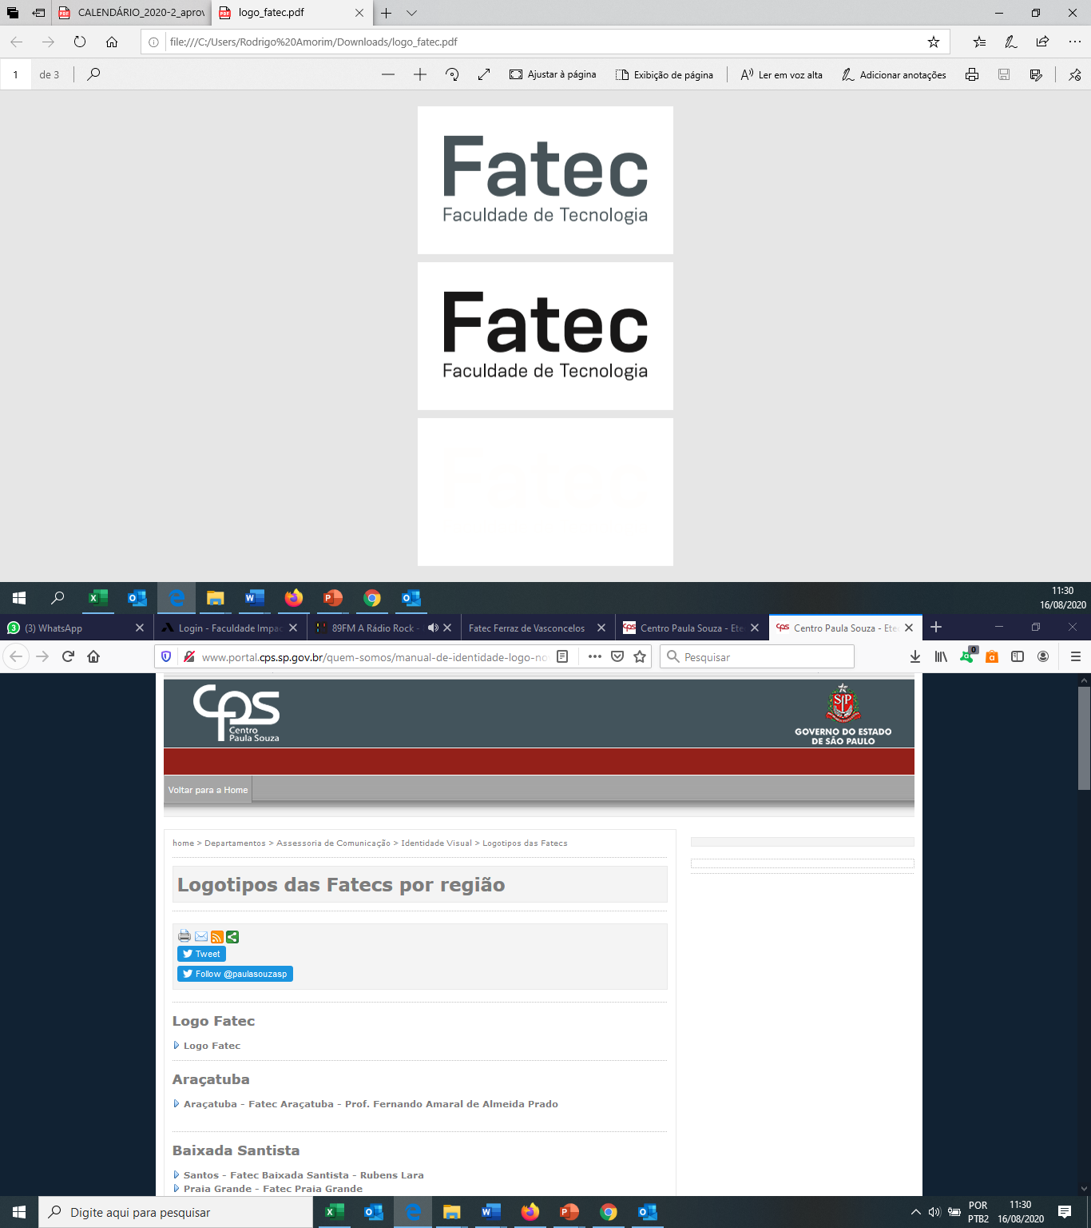

**Arquitetura e Organização de Computadores**

**Prof. Rodrigo Amorim**

**Atividade 1**

**Faça a conversão numérica para a base indicada. Insira a tabela de conversão.**

1. ***200***10 ***= C8***(16)
2. ***7***16 ***= 111***(2)
3. ***F6***16 ***= 246***(10)
4. ***32***10 ***= 100000***(2)
5. ***70***16 ***= 1110000***(2)
6. ***AAA***16 ***= 2730***(10)
7. ***600***10 ***= 1001011000***(2)
8. ***0101111***2 ***= 2F***(16)
9. ***1E0F***16 ***= 1111000001111***(2)

|  |  |  |  |  |  |  |  |  |  |  |  |  |  |  |
| --- | --- | --- | --- | --- | --- | --- | --- | --- | --- | --- | --- | --- | --- | --- |
| **HEX** | **4096** | **2048** | **1024** | **512** | **256** | **128** | **64** | **32** | **16** | **8** | **4** | **2** | **1** | **DEX** |
| **C8** | 0 | 0 | 0 | 0 | 0 | 1 | 1 | 0 | 0 | 1 | 0 | 0 | 0 | **200** |
| **7** | 0 | 0 | 0 | 0 | 0 | 0 | 0 | 0 | 0 | 0 | 1 | 1 | 1 | **7** |
| **F6** | 0 | 0 | 0 | 0 | 0 | 1 | 1 | 1 | 1 | 0 | 1 | 1 | 0 | **246** |
| **20** | 0 | 0 | 0 | 0 | 0 | 0 | 0 | 1 | 0 | 0 | 0 | 0 | 0 | **32** |
| **70** | 0 | 0 | 0 | 0 | 0 | 0 | 1 | 1 | 1 | 0 | 0 | 0 | 0 | **112** |
| **AAA** | 0 | 1 | 0 | 1 | 0 | 1 | 0 | 1 | 0 | 1 | 0 | 1 | 0 | **2730** |
| **258** | 0 | 0 | 0 | 1 | 0 | 0 | 1 | 0 | 1 | 1 | 0 | 0 | 0 | **600** |
| **2F** | 0 | 0 | 0 | 0 | 0 | 0 | 0 | 1 | 0 | 1 | 1 | 1 | 1 | **47** |
| **1E0F** | 1 | 1 | 1 | 1 | 0 | 0 | 0 | 0 | 0 | 1 | 1 | 1 | 1 | **7695** |